Hockering Parish Council

Chairman:  J Blackwell  Tel: 07808 927910  e-mail: jonty.b@btinternet.com | Parish Clerk  Margaret Ridgwell  Tel: 01603 871636  e-mail: hockeringparishcouncil@gmail.com

MINUTES of the Parish Council Meeting held on Tuesday 11th November 2025 at the Village Hall, Hockering.
Cllrs Present at the Meeting: J Blackwell (Chair), G Bambridge, P McIntee and R Neave
Also Present: Parish Clerk and 4 residents.

- Welcome. To receive apologies for absence – Cllr B. Higgins sent his apologies.

- To receive any declarations of interest – Cllr McIntee declared that as he is on the FoHPS committee, he would not vote on any financial matter concerning the Primary School.

- To approve the Minutes of the Parish Council Meeting on the 14th October – having previously been circulated to all councillors, Cllr Neave proposed, and Cllr Bambridge seconded that the Minutes be approved and signed. All agreed.

- To receive County/District Councillor reports – District Cllr Bambridge reported that there was nothing new to report at the moment. In answer to a question concerning the Local Government Reorganisation, he said that there will be an election next year for the position of Mayor of Suffolk and Norfolk, but the date for the election of District and County Councillors has not yet been confirmed. Cllr Borrett’s report is attached to these minutes.

- To receive updates from:
  - Village Hall – It was reported that quotes have been received for the upgrade to the electrics in the Village Hall and work will take place soon. The 5-year inspection of the electrics in the Hall had taken place and the application for a grant to help with the upgrade is progressing.
  - Village Church – There has been no interest to date in the vacancy for a vicar and progress is unlikely until next year. The School Harvest Festival Service took place recently and 4 people attended the Remembrance Service. The Coffee mornings continue to provide much needed income and the next one is planned for the 29th November.
  - Primary School/Friends of Hockering Primary School – The refurbishment of the toilets, in school has been completed. Unfortunately, the ‘Bangers & Bingo’ session in November had to be cancelled due to lack of support. Following discussion, it was suggested that trying to arrange a Bingo session during the day so children could also attend was a bit ambitious, and if held in the evening, refreshments would only need to be simple and prior booking would not be necessary. Cllr McIntee said he would take these suggestions back to the PTA so they could re-assess the arrangements. The PTA are keen to hold another Summer Fete in 2026 but are looking at other, larger sites so additional attractions could be included to appeal to a wider age range of residents.
  - Playing Field – Ownership & Management – Cllr Blackwell has been in contact with the Playing Fields in Trust organisation and an Extraordinary General Meeting needs to be arranged to invite volunteers to join a new restructured Committee. No date for an EGM has been agreed yet. The Charity Commission has not received any updated information on committee personnel or financial reports for several years. If a Charity cannot carry out its responsibilities the Charity Commission can take over but at the moment they seem reluctant to do so without talking to the current Committee. At present the Football Association Committee in the village do not pay rent to the Playing Field Committee, but they do pay for all the services such as insurance, electricity, water, wi-fi, grounds maintenance etc. Cllr Blackwell will continue to try to resolve the issues between the two parties and ensure that this important village amenity is properly managed and maintained.
  - Village Maintenance – Cllr Blackwell reported that he had not yet received a date for when Norfolk Trees will be able to survey and carry out a risk assessment on the trees which are the responsibility of the Parish Council. He will contact them for an update. A Freedom of Information request has been sent to Breckland Council for details of their contract with SERCO to maintain trees in Hockering. This information should be available in the next 3-4 weeks.
  - Footpaths – Cllr McIntee had surveyed all the footpaths in Hockering, some of which are now not in use due to the road improvement works along the A47. FP5 has been closed for safety reasons but a replacement path has been made available by the landowner. Cllr Blackwell will contact the landowner and ask for an update on the current situation and when FP5 will be reinstated. NCC are responsible for the condition of public footpaths and if any are overgrown, or impassable for any reason, anyone can access the NCC website and report a problem with a footpath.

- Open Forum for Public Participation – A resident again raised the issue of road closures in the locality due to the road improvements on the A47, particularly the five-month closure of the A47/Wood Lane junction, starting in November. The inadequacy of road signage giving motorists details of the diversion route well in advance of the actual closure means that additional traffic is now coming through Hockering rather than following the official diversion route. This is a problem particularly affecting HGVs who are now travelling along roads which have a 7.5T weight restriction. Anyone seeing an HGV travelling through Hockering should endeavour to take details of the vehicle and the company involved and pass it on to the Parish Council. The haulage companies will then be contacted to point out that Hockering village is not a designated diversion for the A47 Wood Lane junction closure.
Speeding in the village, particularly along Heath Road, was already a problem and will be even worse with additional traffic. This will, hopefully, be helped when a Hockering Community Speedwatch Group is set up. Volunteers have already come forward to take part and the Speedwatch Group is waiting to hear from the Police with details of training and a date for when the scheme can start.
Another matter raised was the lack of communication in the village now that the Village Newsletter had ceased. It was suggested that a simplified Newsletter could include short reports from village organisations, and a diary section showing upcoming events, which could be printed locally and distributed to every household by volunteers. The matter will be discussed at the next meeting to find the best option. In the meantime, the Parish Council website will be kept up to date and important information included.

- To receive updates on the following Working Parties:
  - Play Area – The Play Area is now closed as the equipment is not safe. Cllrs felt that the Play Area is not in the best location and alternative sites should be looked at before more money is spent on the existing area and equipment.
  - Community Speedwatch Group – As reported in item 6, a Group has been set up and is hoping to start reporting as soon as they are contacted by the Police.
  - Purchase of Village Noticeboard – This has now been erected and looks very smart. Thanks to Cllrs Blackwell and Higgins for their help.
  - Purchase of Gov.uk Emails – These have now been purchased and will be in use shortly. Arrangements will be made to ensure that anyone using the existing email addresses for the Clerk or Councillors will be forwarded to the gov.uk email addresses so communications will not be lost.
  - Purchase of Additional Dog Bins - Cllr McIntee had suggested sites for 3 new dog bins adjacent to footpaths and these sites will be sent to Breckland Council so they can approve the exact location and fixing and add them to their list for emptying. There are already two bins in the village, outside the School and near the bus shelter.

Highway & Footpath Matters – These matters had already been discussed in items above.

Correspondence for circulation – all relevant correspondence had been circulated to councillors and dealt with as required.

- Planning Matters –
  - No planning applications have been received since the last meeting.
  - To clarify matters, Breckland Council do not now have the facility to send weekly reports on applications received and decisions made. Parish Councils need to obtain this information themselves from the public portal: https://publicportal.breckland.gov.uk/planning/index.html. The Clerk will monitor this portal and note any decisions made.

- Finance & Governance Matters
  - To approve the following payments and note Bank Balance – The payments for October were noted and approved by all, following a proposal by Cllr Bambridge, seconded by Cllr Neave.

PAYMENTS FOR APPROVAL THIS MONTH: THE CO-OPERATIVE BANK COMMUNITY ACCOUNT
BALANCE AS AT 31.10.25 |  |  | £25,474.72
PAY TYPE | PAYEE | DESCRIPTION | ACTUAL AMOUNT | VAT
BACS | M Ridgwell | Oct Salary & Exps | 310.20
BACS | HMRC | PAYE to Period 07 | 73.40
BACS | Petrol for mower | Padlock (Pd by B Higgins) | 20.00 | 3.33
BACS | Catton Print | Speedwatch Flyers | 62.00
BACS | Earth Anchors | Village Noticeboard | 756.00 | 126.00
BACS | Norfolk PTS | Training for PM | 62.40 | 10.40
BACS | Norfolk PTS | Training for Clerk | 43.20 | 7.20
 |  | Total | 1,372.20 | 143.60
BALANCE C/FWD 14.10.25 |  |  | £24,147.52

  - To consider expenditure for the new financial year budget – a draft budget will be prepared before the next meeting and any additional expenditure required will be discussed.

- To receive any new items for the next agenda – To progress and receive updates on matters raised above. To consider the Budget for 2026/27, including the Precept required. To consider Council Policies and appoint councillors to oversee particular policies and procedures on a regular basis. To consider the repainting of the village sign.

- To note the next meeting of the Parish Council – This will be on Tuesday 9th December 2025 at 7.30pm in the Village Hall.

The meeting closed at 9.50pm

Signed ………………………………………………………………

Cllr BILL BORRETT
Parish Report for the Elmham and Mattishall Division
November 2025

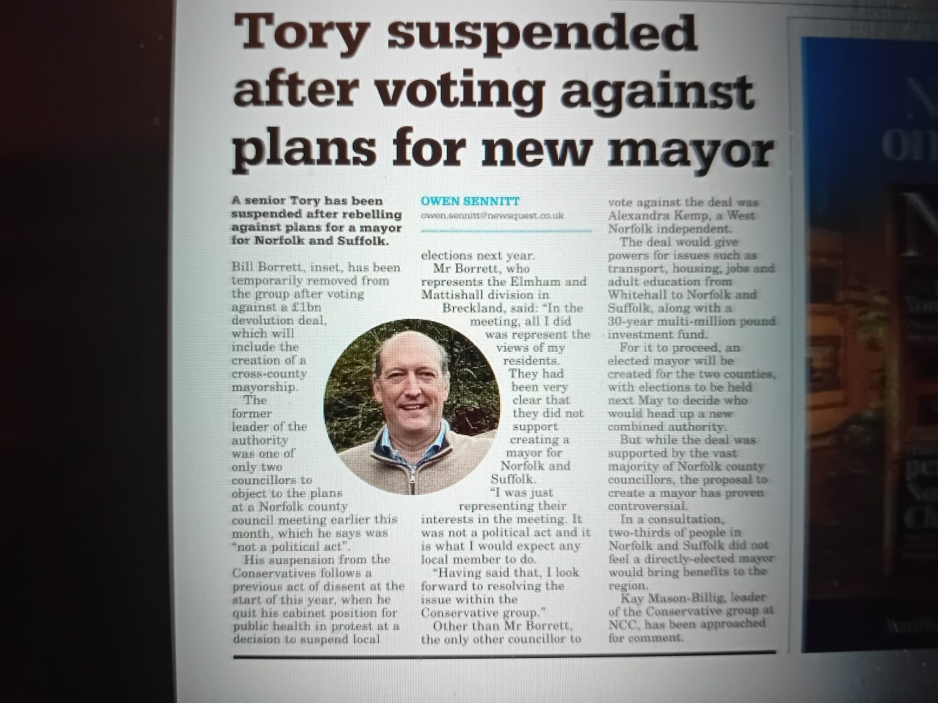

You may have seen this article in the EDP on the 27th October. I am happy to say that I am no longer suspended, but it came about because I listened to your views. I voted against establishing an expensive new Mayor for Norfolk and Suffolk, in line with the feedback I received from you. This was despite being told to vote for it at the County Council.
I have always felt that it is my responsibility to represent the residents of the Elmham and Mattishall Division to the County Council not the other way around. Your views always come first.
New Norfolk-wide highways contract awarded with strong focus on boosting local skills and employment
Norfolk County Council has appointed Kier Limited as its new long-term contractor responsible for the maintenance and construction of Norfolk’s highway network.
Kier will deliver a comprehensive programme of highways maintenance and improvement, including road resurfacing and surface dressing, bridge works, drainage and the delivery of new transport infrastructure.
As part of the contract, Kier will invest significantly in its existing site in Wymondham, upgrading facilities to reduce energy consumption and support the latest in sustainable construction and materials innovation, which will benefit the wider Norfolk economy.
A key feature of Kier's approach to the contract will be its commitment to local skills and employment. At any given time, Kier will employ at least 15 apprentices, providing structured training, professional qualifications, and career pathways for young people across Norfolk.
The company will also run an annual 10-week programme for young people in care and care leavers, offering taster sessions, work experience, and employability skills, with support from supply chain partners.
Most importantly we hope to see quality and timely actions to protect our Highways.

Norfolk bucking national trend for recruiting adoptive parents
Norfolk is bucking the national trend for recruiting adopters, with the numbers of adopters increasing in the county. This is so important as the life chances of children who are adopted are so much greater.
Across the country, there are 12% fewer families considering adoption this year compared to last, whereas in the year 24/25, Norfolk County Council's Adoption Service recruited 43 adoptive households - a 53% increase on the number of adopters who were approved in 23/24.
Of these 43 households, 37 were couples and six were single adopters. The council has also seen an increase in adopters from global majority backgrounds and from the LGBTQ+ community.
The news comes as the county marks “National Adoption Week”, with this year's focus being on busting the misconceptions about who can adopt.
People considering whether adoption is right for them are invited to contact Norfolk Adoption Services on 01603 638343 for a friendly chat and invitation to an information event where they can find out more.
Give Norfolk County Council your views on fire and rescue priorities
A public consultation on Norfolk Fire & Rescue Service's safety and risk plans for the next five years has gone live.
Residents, businesses and organisations now have an opportunity to feedback on areas the service has identified as priorities for 2026-2031, to mitigate risk and keep our county as safe as possible.
Eight proposals have been put out for the public to comment on, around the areas of:
- Road safety
- Prevention activity
- Building safety
- Preparing for and responding to emergencies
- Responding to climate change (specifically extreme weather risks such as flooding and wildfire)
- Supporting our people
- Fire station improvements
- Responding to medical emergencies
Details of the eight proposals are below. The public can fill in an online survey via www.norfolk.gov.uk/crmp to respond.
CRMP Proposal 1
Working to Improve Road safety: We will play a more active role in Norfolk's Road Safety Partnerships to analyse data and coordinate action to reduce the occurrence and impact of collisions on our county's roads.
CRMP Proposal 2
Focussing on prevention: We will work within Community Safety Partnerships to further focus on vulnerable groups, including children and young people. We will increase our early intervention activities, developing resilience in our communities and improving outcomes.
CRMP Proposal 3
Ensuring better Building Safety: We will prioritise inspection and engagement activity for the highest risk buildings in Norfolk, effectively applying legislation across relevant residential and commercial buildings to keep people safe in their homes, at work and during their leisure activities.
CRMP Proposal 4
Enhancing our Response: We will review how we locate and deploy our assets and resources to optimise how we train for, and respond to, emergencies.
CRMP Proposal 5
Responding to Climate Change: We will review our extreme weather response, specifically water and wildfire capability, to mitigate the impact of these incidents. We will continue to lobby government to make water and flood response a statutory duty for all Fire and Rescue Services in England.
CRMP Proposal 6
Supporting our People: We will continue to further develop our high performing and inclusive culture; supporting our staff to be skilled, healthy and engaged, and empowering them to uphold the highest professional standards that our communities expect.
CRMP Proposal 7
Providing Fit for Purpose Fire Stations: We will secure long term investment in our fire stations, so firefighters are protected from contaminants and facilities are fit for a modern workforce.
CRMP Proposal 8
Responding to Life Threatening Medical Emergencies: We will continue to develop our work with East of England Ambulance Service Trust around Emergency Medical Response to improve outcomes for our communities.

Norfolk's budget consultation - Have your say
As the County Council's annual budget consultation has launched, residents are urged to take a look at the proposals and have their say.
The County Council is working to set a balanced budget, despite increased demand for services from Norfolk’s residents.
This year there are 50 budget saving proposals, and proposals to increase Council Tax, which provides a large part of the funding the County Council needs to meet it’s growing obligations.
To help deal with cost pressures and invest in vital services, the current budget planning for 2026-27 includes options to increase council tax.
Three options are being considered:
- An increase of 3%
- An increase of up to 5%
- An increase of more than 5%
People can find out more detail on why these are being considered and have their say at www.norfolk.gov.uk/budget.
The consultation opens on Monday 27 October and closes on Monday 15 December 2025.

'It's never too late': Norfolk County Council is supporting healthy ageing
Looking after your health as you get older is not just a recommendation - it's a vital investment in your future quality of life. Evidence shows that staying physically active, keeping up with recommended vaccinations and screenings, and maintaining social connections are among the strongest predictors of how well you age. These actions play a direct role in preventing illnesses, reducing the risk of falls and long-term conditions, and supporting mental wellbeing.
Norfolk is home to one of the highest ageing populations in the UK. Now, the county council's Public Health department has launched a new campaign to encourage residents aged 50 and over to prioritise their health so they can live healthier, more connected lives as they age.
The campaign is centred around a brand new Healthy Ageing subsite, called 'It's never too late', which highlights resources, guidance and opportunities to help residents make positive changes to their health and wellbeing.
This includes:
- Protecting your health: information on vaccination eligibility and booking, NHS screening appointments, and NHS health checks.
- Being active: information on moving more, strength and balance, falls prevention, and finding local groups.
- Feeling connected: finding clubs, groups and one-to-one support, building new connections, and practical guidance on transport and digital skills.
To explore the new webpage and find out more, visit www.norfolk.gov.uk/healthyageing.

Major refurbishment announced for Millennium Library to mark 25-year anniversary
Norwich's Millennium Library is the flagship Library and the hub from which Norfolk’s Library Service is delivered. It is set to undergo a £1m transformation in 2026, marking 25 years since it first opened its doors.
The refurbishment has been shaped by extensive feedback from library users and will include a re-designed early years library as well as new homes for both the 8+ and teen library areas, each with their own identity. There are also plans for a bookshop-style entrance for easy browsing and an increase in study space, primarily on the first floor.
Accessibility has been a key part of the design with lower shelving units throughout the library and improved signage and wayfinding.
Visitors can also look forward to improved lighting, new furniture with built-in power points and a new gathering space for events and talks.
Work is scheduled to begin next year. While some disruption to services is expected during the refurbishment, full details will be shared closer to the time.

Parish Partnership Scheme
The deadline of the Parish Partnership scheme is fast approaching. All Parishes that are considering putting in bids please make sure that you are doing them now.
I am always delighted to support any proposals as it represents a way to get extra money from Highways for our Parishes.

If you have any queries please do not hesitate to contact me on bill.borrett@hotmail.co.uk

Best wishes
Bill

