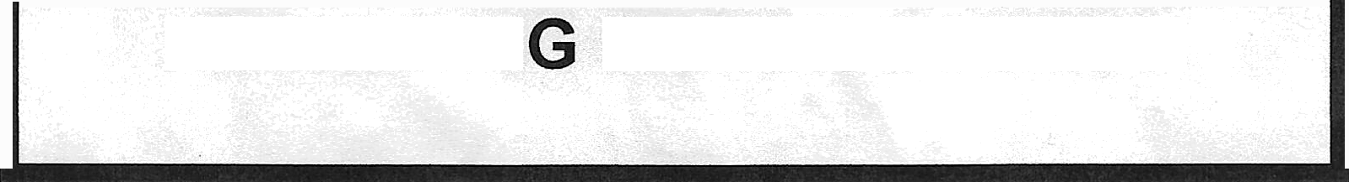
HOCKERIN PARISH COUNCIL
NOTICE OF VACANCY IN THE OFFICE OF

PARISH COUNCILLOR
Notice is hereby given of a vacancy that exists for ONE Parish Councillor to serve on the Hockering Parish Council caused by the resignation of Councillor Pippa Cocker.

Unless within 14 days of the date of this notice, ten electors for Hockering Parish (named on the Electoral Register) have requested to hold an election, the Parish Council will fill the vacancy by co-option as soon as practicable.
All requests (in writing) for an election to fill the vacancy should be sent to:

The Returning Officer Breckland Council Elizabeth House Walpole Loke Dereham
Norfolk NR19 1EE

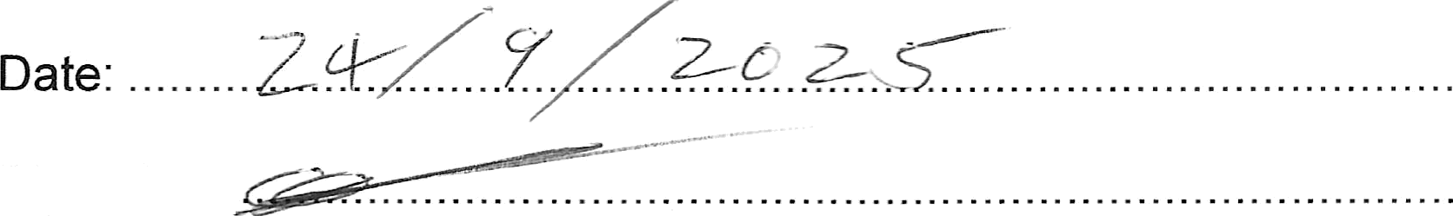
Signed:
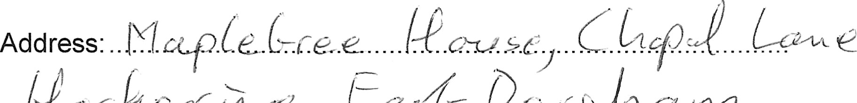
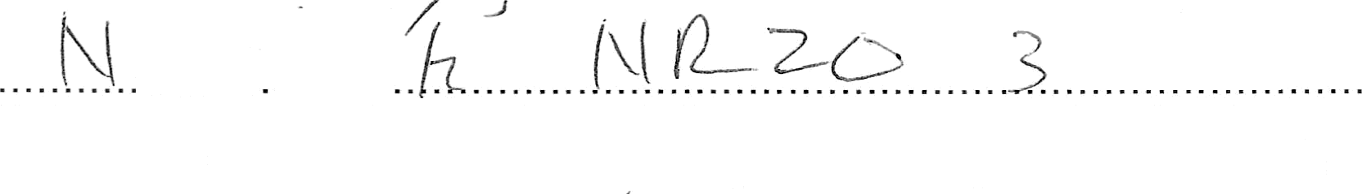
Chairman/Clerk to Parish Council
Note:
’. ..+....
In computing the 14 (and 60) day periods, Saturday, Sundays, Christmas Eve, Christmas Day, Good Friday and bank holidays are disregarded.

Printed and published by the Returning Officer, Breckland Council, Dereham, NR19 1EE

