

Safety Inspection Report
Annual Inspection

Play Area


Hockering Parish Council

01 July 2026





Safety Inspection Report
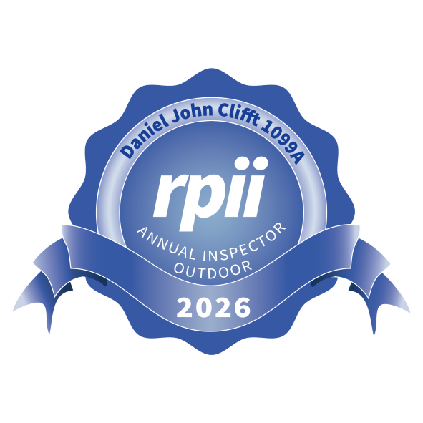
Annual Inspection
Site name: Play Area Date of inspection: 01 July 2026 Inspector: Dan Clifft

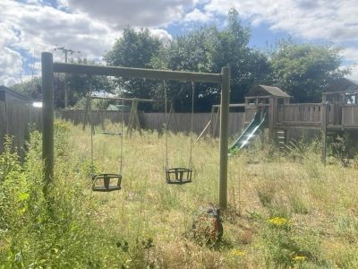

The Overall Site
Description

Tasks
Innate risk score:  0
Risk score

Additional comments are noted below. Read the notes for further action. 12 Excessive weed growth on surfacing. Read the notes for further action. 12 Additional comments are noted below. Read the notes for further action. 12

Signage
Description

Tasks
Innate risk score:  2
Risk score

Dog ban & ownership signs recommended. See https://www.rospa.com/play- 6
safety/advice/signs
Cap missing. Read the notes for further action. 3

Fencing
Description

Tasks
Innate risk score:  4
Risk score

Minor repairs are needed. Repair. 5

Gate
Description

Tasks
Innate risk score: 4
Risk score

The gate is locked and a full inspection of its Ensure the operation of the gate is

operation is not possible.

Seating
Description
The gaps between the slats exceed 30 mm and are known to cause entrapments.

Litter Bin
Description No Findings
checked.

Tasks
No reasonably practicable action is identified.

Tasks

Innate risk score: 3
Risk score 4

Innate risk score: 2
Risk score

Swing - Mixed - 2 Bay 1 Basket 2 Junior Seat
Innate risk score: 8

Description
Tasks
Risk score

Loose fill surfacing less than either: a) 100 mm more than determined by testing to EN 1177 to achieve the critical fall height, b) 300 mm when the fall height is up to 2 m, or c) 400 mm when the fall height is between 2 m and 3 m.

Top up. 14

Timber is decayed. Read the notes for further action. 14

The geo-textile is exposed. Secure beneath surface and ensure 9

minimum depths are maintained.

Timber is decayed. Check on a routine basis. 6

The supporting components should be dismantled and inspected according to the manufacturer's instructions. This will need doing on a regular basis, as defined by the manufacturer. This can lead to a high risk if no action is taken.

Dismantle and inspect according to 5

manufacturer's instructions.

Swing - Toddler - 1 Bay 2 Seat
Innate risk score: 4

Description
Tasks
Risk score

Corrosion in cradle seat top frame could lead to sudden failure of the seat.

Investigate and replace as necessary. 12

Timber is decayed. Read the notes for further action. 8
Bolt(s) loose. Tighten. 8

Swing seat rubber is deteriorating / degrading.
This equipment relies on one post for its stability. Special attention should be paid to maintenance (e.g. by monitoring degradation) and if necessary decommissioning the item before the end of its operating life. This is a requirement of
There are natural splits / shakes in the timbers.
Monitor and replace when hard 6
material is exposed.
Consult with the manufacturer's 6
guidance to determine suitable
maintenance.

Shakes vary. Monitor and consult 6
manufacturer if dimensions exceed 8
mm at sections used to grip / grasp.

Cap missing. Replace. 5

Multiplay - Junior
Description
Overhead ladders and rings provide significant play value and benefits to children, and with it the risk of falling. Ensuring the surface remains in good condition will help to keep the correct balance between benefits and risk.
There are natural splits / shakes in the timbers.

Tasks
The protective surface under all bars and rings must be kept in good condition.

DO NOT fill shakes. Monitor and sand back any splintered edges as required.

Innate risk score: 6
Risk score 8

6

There is significant corrosion on this item. De-scale back to good metal and coat 6
with lead free paint, using appropriate
precautions. Repairs may be necessary where corrosion is severe.

This equipment relies on one post for its stability. Special attention should be paid to maintenance (e.g. by monitoring degradation) and if necessary decommissioning the item before the end of its operating life. This is a requirement of
Consult with the manufacturer's 6
guidance to determine suitable
maintenance.

There are sharp edges or projections. Remove the sharp/projecting parts. 6
Item is damaged. Repair. 5
Fixtures loose or missing. Tighten. 5
Timber is decayed. Read the notes for further action. 5

Multiplay - Toddler
Description

Tasks
Innate risk score: 5
Risk score

Fixtures loose or missing. Replace.  8
Item is rusting in places. Repair. 6

There is a toggle entrapment. Eliminate the entrapment. 6

A head/neck entrapment is present in a partially bound opening.

No reasonably practicable action is 6
identified.

Fixtures loose or missing. Tighten. 5
Item is damaged. Repair. 5
Cap missing. Replace. 3

Rocker - Bird
Description No Findings

Rocker - Daisy
Description

Tasks

Tasks
Innate risk score: 3
Risk score

Innate risk score: 3
Risk score

Cap missing. Replace. 3


The assets on site are categorised as Ancillary Items or Play Items, and listed under those headings.
Each item is listed in the style shown in the image below, which contains labels to aid interpretation as follows:
- The name of the asset
- The manufacturer of the asset, if known,
- The innate or default risk score of the asset, assuming it has no faults and complies with standards,
- The actual risk score of the asset at the time of inspection, being the highest of the finding risks or the innate risk,
- A statement about whether the item complies with the appropriate standards, including the names of those standards,
- Details about findings, if any, including what is wrong (Description), what to do about it (Tasks), notes to aid understanding (Notes), and photograph(s) of the issue.
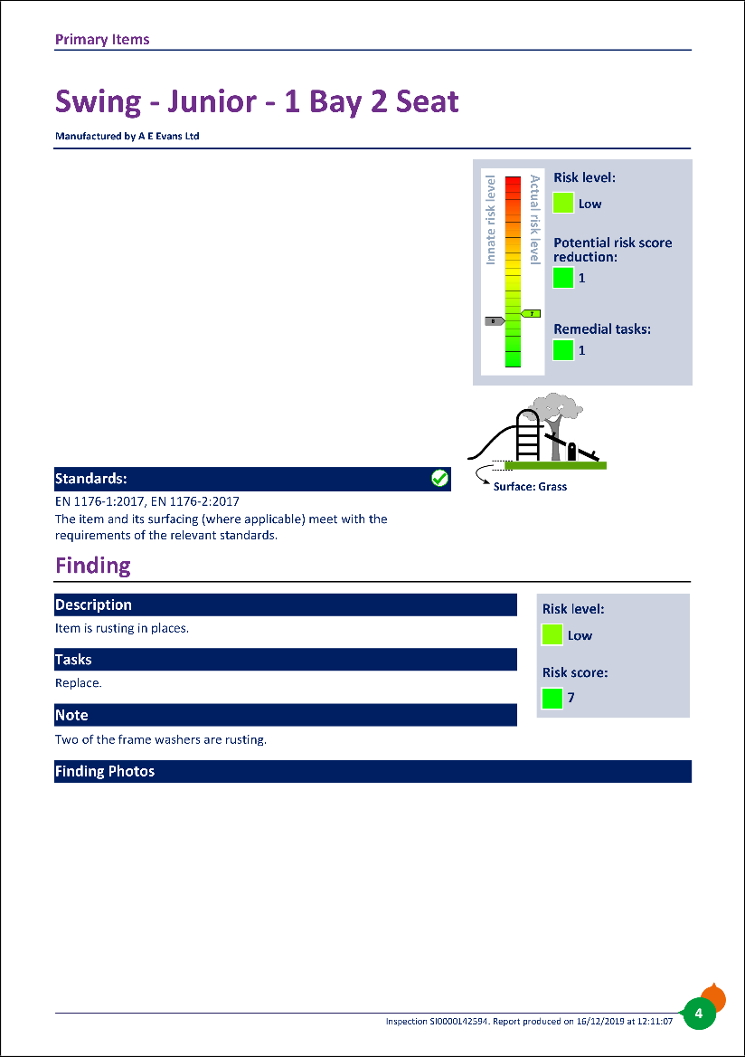




1
Manufactured by Manufacturer Name
2
asset image here
3
4
5
6

asset image here

asset image here
Sample Asset Name

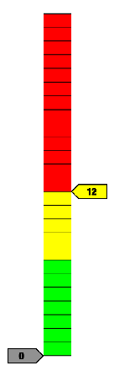
The Overall Site
Risk level:
Medium

Potential risk score reduction:
12

Remedial tasks: 3
Actual risk level
Innate risk level
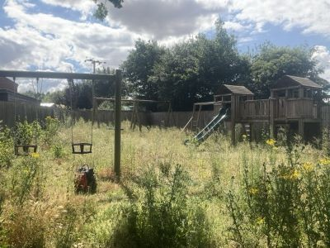

Maintenance Finding

Description
Risk level:
Medium

Risk score: 12

Additional comments are noted below.
Tasks
Read the notes for further action.

Note
The site has been closed off due the unsafe equipment on site. Part of a fence panel has been removed, allowing access in the play area. The inspector recommends removing all swing seats/suspensions until the park is ready to open repair fencing.

Finding Photos
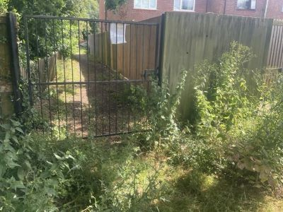
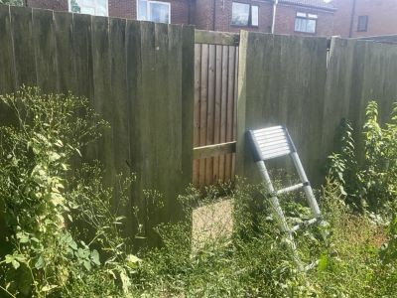

Maintenance Finding
Description
Finding Photos
Risk level:
Medium

Risk score: 12
Risk level:
Medium

Risk score: 12

Excessive weed growth on surfacing.
Tasks

Read the notes for further action.
Note

Remove weed growth and top up loose fill around all play items.
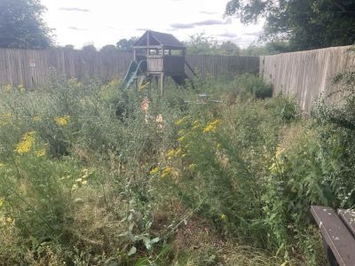
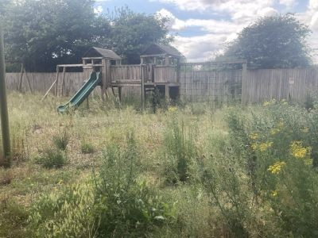
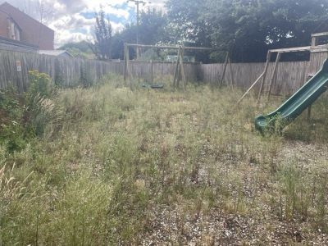
Finding Photos

Maintenance Finding

Description

Additional comments are noted below.
Tasks

Read the notes for further action.
Note

With decay found in several posts. The inspector recommends a resistance penetration test is carried out on all supports to determine their condition.
Photo not possible

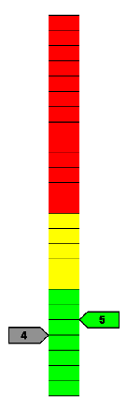
Fencing
Risk level:
Low

Potential risk score reduction:
1

Remedial tasks: 1
Actual risk level
Innate risk level
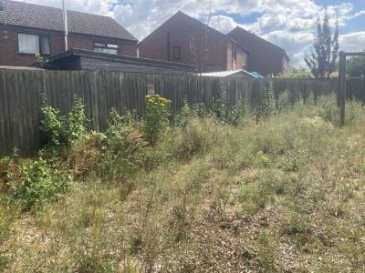

Maintenance Finding

Description
Risk level:
Low

Risk score: 5

Minor repairs are needed.
Tasks
Repair.

Note
Fence rail damaged and boards loose/damaged. Repair.

Finding Photos
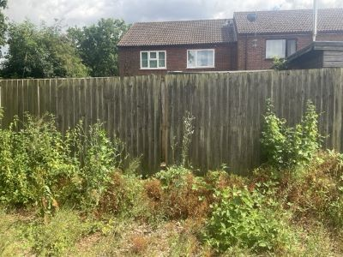

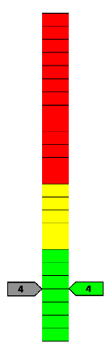

Gate
Risk level:
Low

Risk score as low as possible

Remedial tasks: 1
Actual risk level
Innate risk level
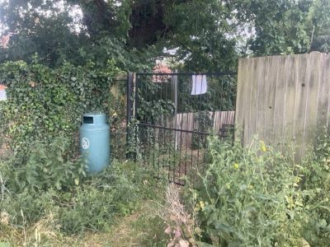

Maintenance Finding

Description
Risk level:
See finding details
The gate is locked and a full inspection of its operation is not possible.

Tasks
Ensure the operation of the gate is checked.

Finding Photos
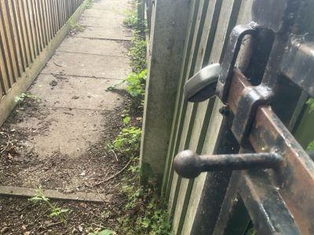

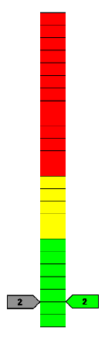
Litter Bin
Risk level:
Very low

Risk score as low as possible

No remedial tasks
Actual risk level
Innate risk level
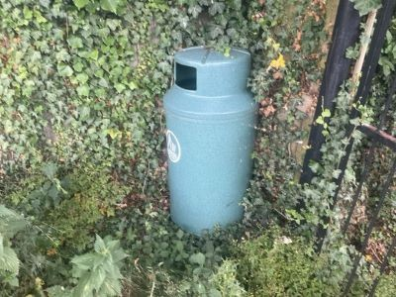

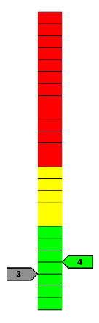
Seating
Risk level:
Low

Potential risk score reduction:
1

Remedial tasks: 1
Actual risk level
Innate risk level
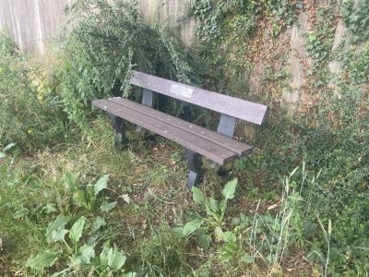

Maintenance Finding

Description
Risk level:
Low

Risk score: 4

The gaps between the slats exceed 30 mm and are known to cause entrapments.
Tasks
No reasonably practicable action is identified.

Finding Photos
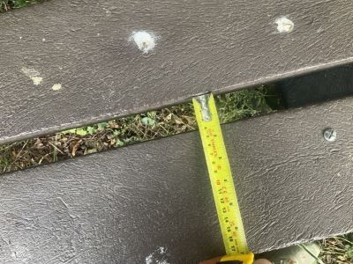

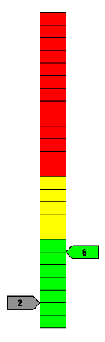
Signage
Finding Photos
Risk level:
Low

Potential risk score reduction:
4

Remedial tasks: 2
Actual risk level
Innate risk level
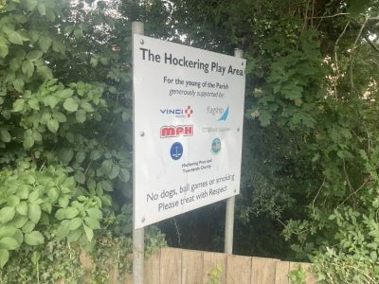

Maintenance Finding

Description
Risk level:
Low

Risk score: 6

Dog ban & ownership signs recommended.
Tasks
See https://www.rospa.com/play-safety/advice/signs

Photo not possible

Maintenance Finding
Description
Cap missing.
Read the notes for further action.
Note
Tasks
Risk level:
Very low

Risk score: 3
Post cap x 1 missing. Replace.

Finding Photos
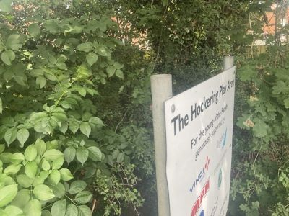

Multiplay - Junior

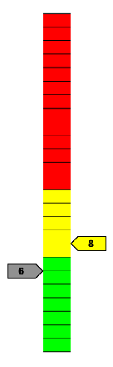
Manufactured by (Unknown)
Risk level:
Medium

Potential risk score reduction:
2

Remedial tasks: 8
Actual risk level
Innate risk level
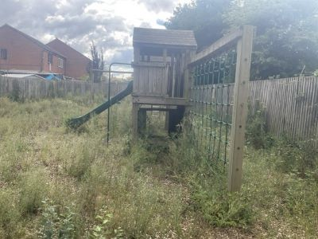

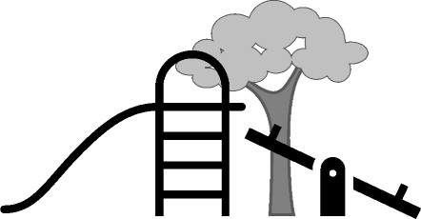
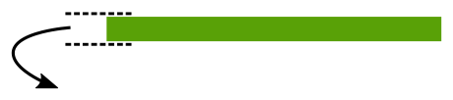
Standards:
EN 1176-1:2017+A1:2023
The item and its surfacing (where applicable) meet with the requirements of the relevant standards.

Maintenance Finding

Surface: Bark / Woodchip

Description
Risk level:
Medium

Risk score: 8
Overhead ladders and rings provide significant play value and benefits to children, and with it the risk of falling. Ensuring the surface remains in good condition will help to keep the correct balance between benefits and risk.

Tasks
The protective surface under all bars and rings must be kept in good condition.

Finding Photos
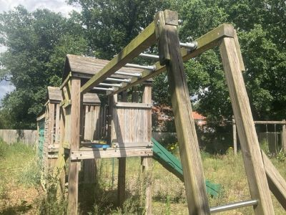

Maintenance Finding
Risk level:
Low

Risk score: 6

Description

There are natural splits / shakes in the timbers.
Tasks
DO NOT fill shakes. Monitor and sand back any splintered edges as required.

Finding Photos
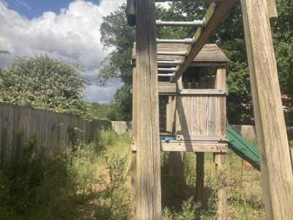

Maintenance Finding

Description
Risk level:
Low

Risk score: 6

There is significant corrosion on this item.
Tasks
De-scale back to good metal and coat with lead free paint, using appropriate precautions. Repairs may be necessary where corrosion is severe.

Finding Photos
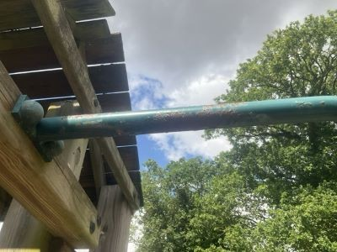

Maintenance Finding
Description
Risk level:
Low

Risk score: 6
Risk level:
Low

Risk score: 6

This equipment relies on one post for its stability. Special attention should be paid to maintenance (e.g. by monitoring degradation) and if necessary decommissioning the item before the end of its operating life. This is a requirement of the British Standard.
Tasks

Consult with the manufacturer's guidance to determine suitable maintenance.
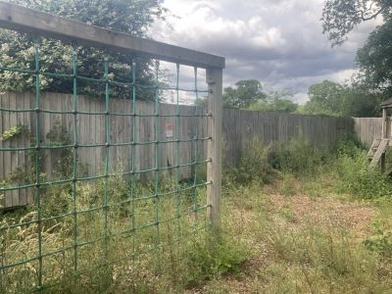
Finding Photos

Maintenance Finding

Description

There are sharp edges or projections.
Tasks

Remove the sharp/projecting parts.
Note

Remove protruding bolt.
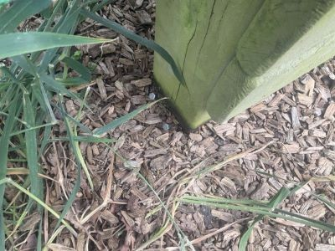
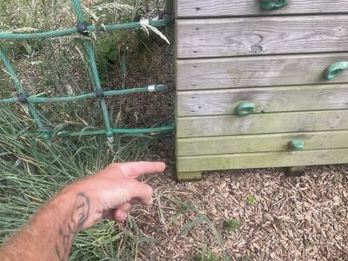
Finding Photos

Maintenance Finding
Description
Risk level:
Low

Risk score: 5
Risk level:
Low

Risk score: 5

Item is damaged.
Tasks

Repair.
Note

OXO panel missing, leaving damaged timber in place. Sand back rough and splintered edges.
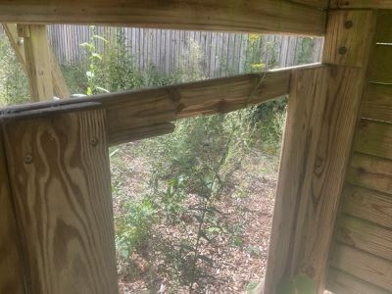
Finding Photos

Maintenance Finding

Description

Fixtures loose or missing.
Tasks

Tighten.
Note

Hand grips loose. Secure.
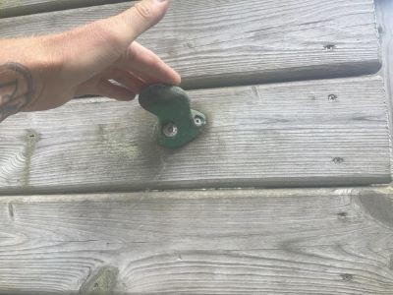
Finding Photos

Maintenance Finding
Risk level:
Low

Risk score: 5

Description

Timber is decayed.
Tasks
Read the notes for further action.

Note
Sand back rough/splintered edges and monitor for any further deterioration.

Finding Photos
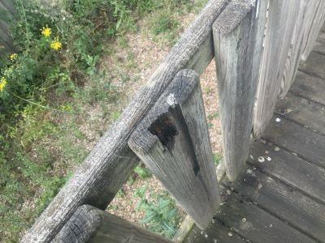

Multiplay - Toddler

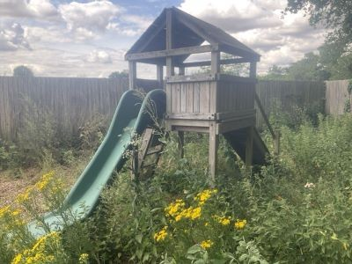
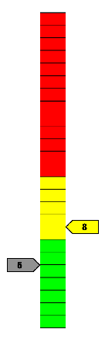
Manufactured by (Unknown)
Risk level:
Medium

Potential risk score reduction:
3

Remedial tasks: 7
Actual risk level
Innate risk level


EN 1176-1:2017+A1:2023

Surface: Bark / Woodchip
Standards:
The surfacing meets with the requirements of the relevant standards. The item is not compliant with the requirements of the relevant standards for the following reasons:
Equipment Standard Compliance Findings
- There is a toggle entrapment.
- A head/neck entrapment is present in a partially bound opening.
The item has the following maintenance findings:
- Fixtures loose or missing.
- Item is rusting in places.
- Fixtures loose or missing.
- Item is damaged.
- Cap missing.

Standard Compliance Finding
Description
Risk level:
Low

Risk score: 6
Risk level:
Low

Risk score: 6

There is a toggle entrapment.
Tasks

Eliminate the entrapment.
Note

Secure the top of the slide.
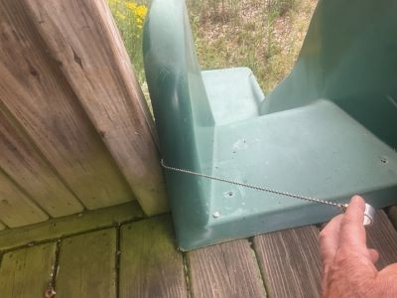
Finding Photos

Standard Compliance Finding

Description

A head/neck entrapment is present in a partially bound opening.
Tasks

No reasonably practicable action is identified.

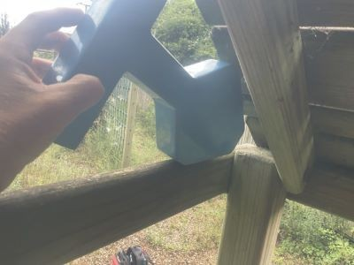
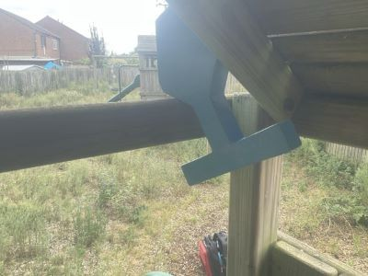
Finding Photos

Maintenance Finding
Description
Risk level:
Medium

Risk score: 8
Risk level:
Low

Risk score: 6

Fixtures loose or missing.
Tasks

Replace.
Note

Slide can be lifted from its supports.
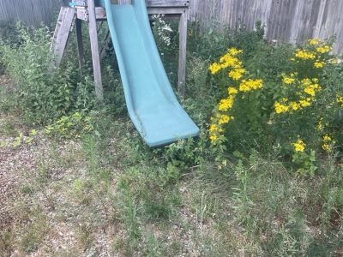
Finding Photos

Maintenance Finding

Description

Item is rusting in places.
Tasks

Repair.
Note

Slide supports rusting and loose in the ground. Treat and reset.
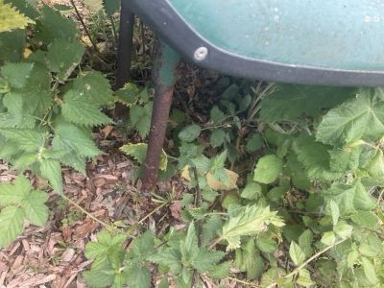
Finding Photos

Maintenance Finding
Risk level:
Low

Risk score: 5

Description

Fixtures loose or missing.
Tasks
Tighten.

Finding Photos
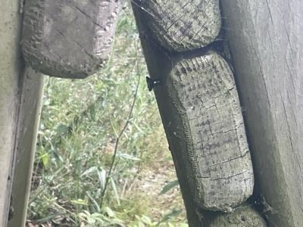

Maintenance Finding

Description
Risk level:
Low

Risk score: 5

Item is damaged.
Tasks
Repair.

Finding Photos
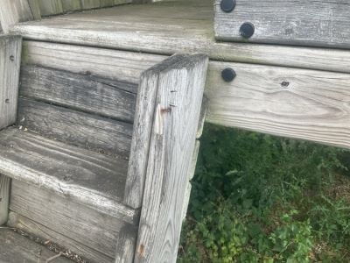

Maintenance Finding
Description
Cap missing.
Replace.
Tasks
Risk level:
Very low

Risk score: 3

Finding Photos
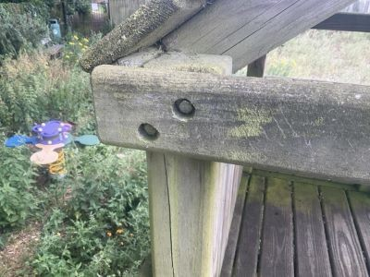

Rocker - Bird

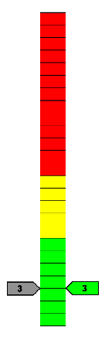
Manufactured by Fahr Industries Ltd
Risk level:
Very low

Risk score as low as possible

No remedial tasks
Actual risk level
Innate risk level
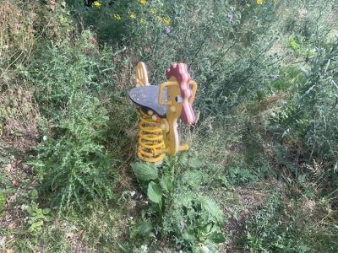

Standards:
EN 1176-1:2017+A1:2023, EN 1176-6:2017

The item and its surfacing (where applicable) meet with the requirements of the relevant standards.
Surface: Bark / Woodchip

Rocker - Daisy

Manufactured by Fahr Industries Ltd
Risk level:
Very low

Risk score as low as possible

Remedial tasks: 1
Actual risk level
Innate risk level
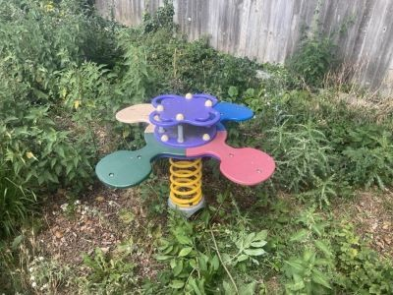

Standards:
EN 1176-1:2017+A1:2023, EN 1176-6:2017
The item and its surfacing (where applicable) meet with the requirements of the relevant standards.

Maintenance Finding

Surface: Bark / Woodchip

Description
Cap missing.
Replace.
Tasks
Risk level:
Very low

Risk score: 3

Finding Photos
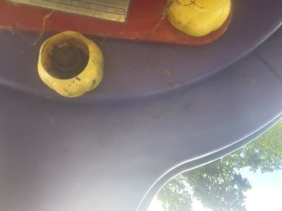

Swing - Mixed - 2 Bay 1 Basket 2 Junior Seat

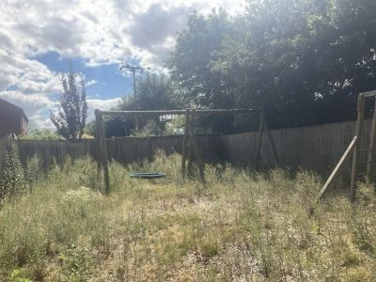
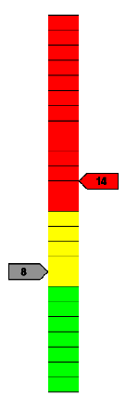
Manufactured by (Unknown)
Risk level:
High

Potential risk score reduction:
6

Remedial tasks: 5
Actual risk level
Innate risk level


EN 1176-1:2017+A1:2023, EN 1176-2:2017

Surface: Bark / Woodchip
Standards:
The item complies with the requirements of the relevant standards. The surface does not comply with the requirements of the relevant standards for the following reasons:
Surfacing Standard Compliance Findings
- Loose fill surfacing less than either: a) 100 mm more than determined by testing to EN 1177 to achieve the critical fall height, b) 300 mm when the fall height is up to 2 m, or c) 400 mm when the fall height is between 2 m and 3 m.
The item has the following maintenance findings:
- Timber is decayed.
- The geo-textile is exposed.
- Timber is decayed.
- The supporting components should be dismantled and inspected according to the manufacturer's instructions. This will need doing on a regular basis, as defined by the manufacturer. This can lead to a high risk if no action is taken.

Standard Compliance Finding
Description
Risk level:
High

Risk score: 14
Risk level:
High

Risk score: 14

Loose fill surfacing less than either: a) 100 mm more than determined by testing to EN 1177 to achieve the critical fall height, b) 300 mm when the fall height is up to 2 m, or c) 400 mm when the fall height is between 2 m and 3 m.
Tasks

Top up.
Note

Surface worn exposing a hard compact surface with protruding rocks.
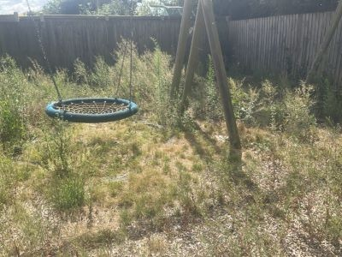
Finding Photos

Maintenance Finding

Description

Timber is decayed.
Tasks

Read the notes for further action.
Note

Supports rotten at ground level on 3 flat seat supports.
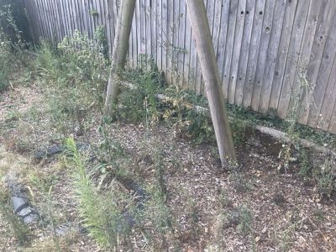
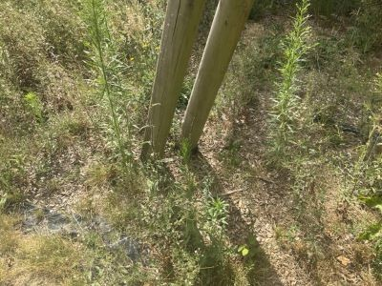
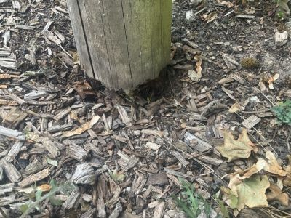
Finding Photos

Maintenance Finding
Description
Risk level:
Medium

Risk score: 9
Risk level:
Low

Risk score: 6

The geo-textile is exposed.
Tasks

Secure beneath surface and ensure minimum depths are maintained.
Note

Replace damaged sections and top up surfacing.
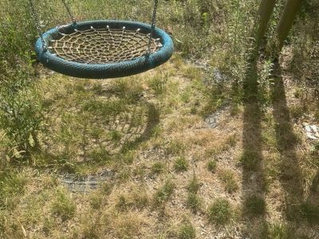
Finding Photos

Maintenance Finding

Description

Timber is decayed.
Tasks

Check on a routine basis.
Note

Softening around the remaining supports below ground level. Monitor closely.
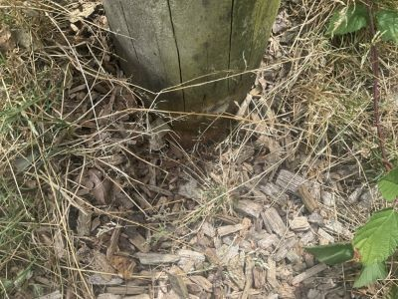
Finding Photos

Maintenance Finding
Risk level:
Low

Risk score: 5

Description
The supporting components should be dismantled and inspected according to the manufacturer's instructions. This will need doing on a regular basis, as defined by the manufacturer. This can lead to a high risk if no action is taken.

Tasks
Dismantle and inspect according to manufacturer's instructions.

Finding Photos
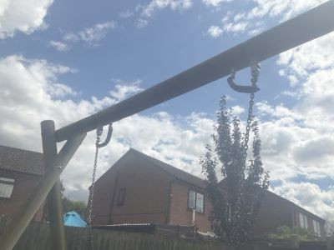

Swing - Toddler - 1 Bay 2 Seat

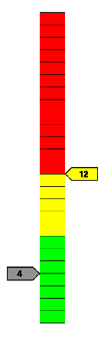
Manufactured by (Unknown)
Risk level:
Medium

Potential risk score reduction:
8

Remedial tasks: 7
Innate risk level
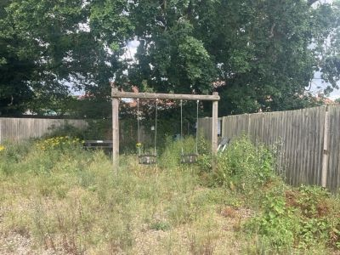

Standards:
Actual risk level
EN 1176-1:2017+A1:2023, EN 1176-2:2017
The item and its surfacing (where applicable) meet with the requirements of the relevant standards.

Maintenance Finding

Surface: Bark / Woodchip

Description
Risk level:
Medium

Risk score: 12

Corrosion in cradle seat top frame could lead to sudden failure of the seat.
Tasks
Investigate and replace as necessary.

Finding Photos
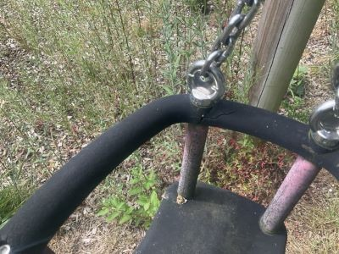

Maintenance Finding
Description
Risk level:
Medium

Risk score: 8
Risk level:
Medium

Risk score: 8

Timber is decayed.
Tasks

Read the notes for further action.
Note

Support x 1 rotting. Monitor closely and plan replacement.
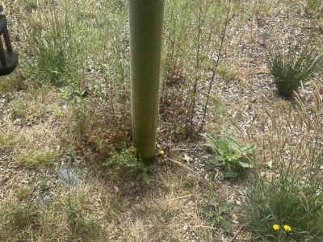
Finding Photos

Maintenance Finding

Description

Bolt(s) loose.
Tasks

Tighten.
Note

Swing hanger bolts are loose. Secure.
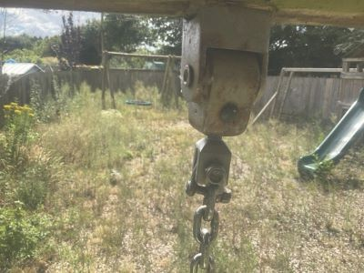
Finding Photos

Maintenance Finding
Risk level:
Low

Risk score: 6

Description

Swing seat rubber is deteriorating / degrading.
Tasks
Monitor and replace when hard material is exposed.

Finding Photos
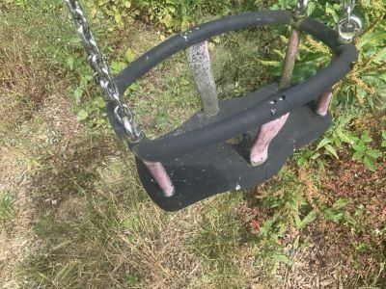

Maintenance Finding

Description
Risk level:
Low

Risk score: 6
This equipment relies on one post for its stability. Special attention should be paid to maintenance (e.g. by monitoring degradation) and if necessary decommissioning the item before the end of its operating life. This is a requirement of the British Standard.

Tasks
Consult with the manufacturer's guidance to determine suitable maintenance.

Finding Photos
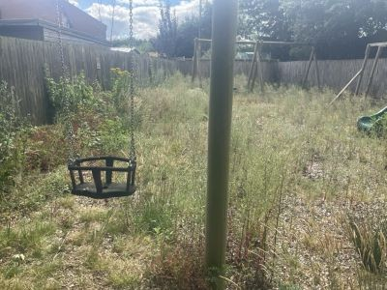

Maintenance Finding
Risk level:
Low

Risk score: 6

Description

There are natural splits / shakes in the timbers.
Tasks
Shakes vary. Monitor and consult manufacturer if dimensions exceed 8 mm at sections used to grip / grasp.

Note
Monitor for decay forming within the shakes on the crossbar.

Finding Photos
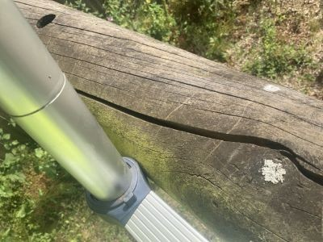

Maintenance Finding

Description
Risk level:
Low

Risk score: 5

Cap missing.
Tasks
Replace.

Finding Photos
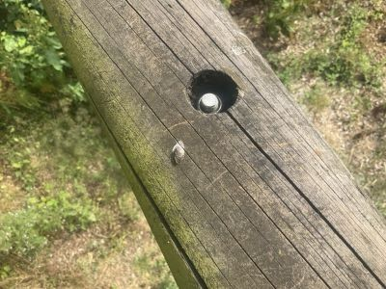

The risk scores are calculated by plotting the likelihood of harm against the severity of the injury sustained. The likelihood is given a score of 1 to 5, and the severity is given a score of 1 to 5. In doing this a matrix is produced which gives a numerical assessment of the risk on a score of 1 to 25, and a judgement is made as to which risks are low, which are medium and which are high. Risk scores may be adjusted in the light of experience and therefore may not be exactly as per the table. For example, a score of 7 may be noted.
Risks are calculated in this way:

- An assessment of the likelihood of harm taking place is made using the numbers 1 to 5, by following these descriptions:
  - 1 = Rare
  - 2 = Unlikely
  - 3 = Moderate
  - 4 = Likely
  - 5 = Certain
- An assessment of the severity of the injury sustained is made using the numbers 1 to 5, by following these descriptions:
  - 1 = Insignificant
  - 2 = Minor
  - 3 = Moderate
  - 4 = Major
  - 5 = Catastrophic
- The two numbers are multiplied to give a risk score on a scale of 1 to 25.
- Scores of 1 to 7 inclusive are considered to be low risk and are considered to be tolerable where this is the innate risk of the item, but where remedial works are identified these should be undertaken,
- Scores of 8 to 12 are considered to be medium risk and some control measures may be identified to reduce the risks to low, tolerable levels,
- Score of 13 and above are considered to be high risk and urgent action is considered to be necessary to reduce the risks to tolerable levels.

It is important to note that where an outcome is catastrophic, but for which the likelihood is rare this will present a score of 1 x 5 = 5 = low risk. Similarly, a certain event for which the consequence is insignificant will present a score of 5 x 1 = 5 = low risk. It is important to consider likelihood and consequence, and not just one of the factors in isolation.
The multiplication of the factors into a risk matrix is given here in Table 1, with a judgement made as to risk scoring indicated by colour.
Green = LOW risk, Amber = MEDIUM risk, Red = HIGH risk. Table 1 – Risk Score Matrix
 | Severity
L  i k e l i h o o d |  | 1  Insignifi-cant | 2  Minor | 3  Moderate | 4  Major | 5  Catastro-phic
L  i k e l i h o o d | 1 = Rare | 1  LOW | 2  LOW | 3  LOW | 4  LOW | 5  LOW
L  i k e l i h o o d | 2 = Unlikely | 2  LOW | 4  LOW | 6  LOW | 8  MEDIUM | 10  MEDIUM
L  i k e l i h o o d | 3 = Moderate | 3  LOW | 6  LOW | 9  MEDIUM | 12  MEDIUM | 15  HIGH
L  i k e l i h o o d | 4 = Likely | 4  LOW | 8  MEDIUM | 12  MEDIUM | 16  HIGH | 20  HIGH
L  i k e l i h o o d | 5 = Certain | 5  LOW | 10  MEDIUM | 15  HIGH | 20  HIGH | 25  HIGH

Inspection Scope
The inspections are undertaken using the RPII’s inspection scope.
Compliance with Standards
Inspections are undertaken with reference to the appropriate standards, which are listed next to each item. Compliance with these standards is not mandatory in law, but it is useful to know whether items comply or not. If we think a change is needed, then this is noted in our report. Non-compliance does not necessarily mean that a change is needed. Where a standard is undated the current version is applied, unless overlap periods are allowed by the standards committee at the time of update. The information provided herein is to assist the owner/operator to fulfil its responsibilities as detailed in the relevant standards. Other standards referenced within the listed standards do not form part of this inspection, unless they are also explicitly listed here.
The listed standards are relevant to all installations of equipment which are publicly accessible, including public parks, pay to play parks, schools, nurseries, public houses, holiday parks, indoor play centres, farm parks and the like. All equipment used in publicly accessible areas should meet with the requirements of the relevant listed standard.

Additionally, EN 1176-7 provides guidance on installation, inspection, maintenance and operation to owners/operators of equipment and ancillary items. In the United Kingdom the National Foreword forms an important part to the understanding and implementation of the recommendations set out in EN 1176-7. It clarifies the application of the document within the UK as best practice guidance, as the document has been used since its initial publication. Therefore the EN 1176-7 contains no requirement in the UK and needs to be read and implemented as guidance, with the use of the terms ‘shall’ therefore becoming a recommendation, as in the term ‘should’.
Domestic equipment falls outside the scope of standards for publicly accessible spaces. Domestic play equipment has its own standard (BS EN 71 – Safety of Toys). Where domestic equipment can be identified this will be acknowledged in the report, but compliance may be assessed to the applicable standard relating to publicly accessible equipment.
When water play items, including spray parks, are inspected any comments concerning compliance within the inspection will refer to EN 1176. We have not assessed these against the requirements of EN 17232 (Water play equipment and features).
Compliance with standards is not always a clear-cut thing. Some interpretation can be needed, and our interpretation may differ from the interpretation of others. In some cases, we may decide not to note non-compliance in cases where we think it may mislead or be unhelpful so to do.

What We Inspect
Annual and Post Installation inspections will take into consideration compliance with current standards and defects related to wear and vandalism. Items not listed in the report have not been included in the inspection. The inspection will cover the playground equipment and the active area (that area which is obviously part of the playground), nominally up to 3.0 metres around, the fence line if closer, or other areas as agreed.
Operational inspections only take into consideration defects related to cleanliness, equipment ground clearances, ground surface finishes, exposed foundations, sharp edges, missing parts, excessive wear (of moving parts), structural integrity, wear and vandalism. Routine visual inspections (if undertaken) relate only to the most obvious defects such as broken or missing parts, vandalism and issues created by severe weather conditions (the intention is to identify hazards created by storm damage).
The inspection is non-dismantling, non-destructive and does not include any structural, toxicology or impact assessments defined in the standard; however, the inspector will undertake a manual test for stability and if equipment fails under manual load, or any other hazard is identified as an unacceptable risk, the owner/operator will be notified as soon as practicably possible.
The inspector will access all reasonably accessible equipment and will assess all reasonably accessible parts above the standing surface. Where it is not possible to access parts of the equipment without employing an alternative means of access the report will record the action required by the owner/operator to ensure the continued safe use of the equipment. Ancillary equipment will be assessed using the inspector’s knowledge and experience of the standards named in this document to ensure as far as is reasonably practicable the continued safe use of the items concerned. The owner/operator is responsible for the overall safety of the equipment and area. Inspectors who are trained to use ladders may use them where it is safe to do so, but if members of the public are present on site ladders may not be used to access the equipment.
What We Don’t Inspect
The inspector will not undertake any of the following works unless specifically agreed in writing at the time of order:
Checking the depth and underlying structural integrity of any surface areas and/or carrying out any testing of impact absorbing properties of any surfaces. The identification of any corrosion, rot or other deterioration in any apparatus or equipment other than by an external inspection or the inspection of any equipment (or part thereof) that is underground or beneath the playing surface. Tightening any bolts, hinges or other fixing devices on any apparatus or equipment. Assessing or inspecting any electrical installations contained on any site and/or apparatus and/or equipment. Assessing or inspecting any water supplies and/or water features and/or any associated computerised systems (including carrying out any programming).

The owner/operator should have a ‘design risk assessment’ provided by the manufacturer/designer of the area for the equipment and location in which the facility is installed.
We have inspected without dismantling or destruction and so some aspects of the relevant standards may not be testable on site.
The operator is responsible for managing risks of their provision and is required by law to carry out a ‘suitable and sufficient assessment’ of the risks associated with a site or activity and this inspection shall be considered as contributing to the operator's discharge of this responsibility.
Exposure to Risk
Exposure to acceptable levels of risk and challenge is essential to children’s development and allows them to exercise their right to play. Therefore, it can be judged that levels of risk above low risk can be acceptable. The risk scores shown allow the operator to make a judgement after first considering the benefit of the activity to which the risk score relates.

Ownership
There may be cases where we report issues that are not the site owner’s responsibility. It is not necessarily possible for us to determine who owns what, and in any case we need to bring all risks to your attention if they can affect the safety of the site’s users.
Contemporaneous Findings
Our report shows the findings at the time of inspection. Subsequent events may affect the condition of the site. Suggested remedial actions are based upon our knowledge and experience. The owner/operator should seek the advice of the manufacturer or a competent person when undertaking repairs and/or modifications to equipment.
Timber
Where timbers are set into the ground it is not always possible to determine levels of decay. The owner/operator should ensure it conducts appropriate inspections to identify decay before it becomes a problem.
We can undertake more in-depth testing of your playground timbers using resistance penetration.
Timber is known to decay from the inside out. This makes it very important that you ensure proper testing and inspection is undertaken of your playground timbers, especially where defects may be hidden inside the structures. Testing using resistance penetration can help to identify defects before they become outwardly apparent, but can also confirm the condition of good timbers to prevent premature replacement with its associated costs.
The testing is undertaken using a specialist machine, which uses electronically controlled drill resistance measurement. The drill is fine enough that it does not cause permanent damage to reduce the lifespan of the equipment.
Please contact us for pricing and further information.
Planting and Trees
Where planting or trees are mentioned in our report, please be advised that we do not undertake any arboricultural, horticultural or toxicological assessment of suitability or condition. You must ensure you undertake suitable inspections from an appropriate expert.

How This Inspection Contributes to Your Annual Main Inspection
The owner/operator is responsible for following the guidance of the relevant standards. The standards give guidance on the installation, inspection, maintenance and operation of the various types of facility. The inspection guidance is listed in Table 1, with an indication of which parts will be included in your RoSPA inspection [the items in the first column are the items which comprise an “Annual Main Inspection”, the second column shows which elements form part of a RoSPA inspection, items with a cross are not included, some items may have limitations as shown in the notes to the Table 1). The standards also contain additional parts which the owner/operator should follow.
Table 1
Inspection Recommendations of relevant standards These form the Annual Main Inspection | Included in RoSPA  Inspection?
6.1 d) Overall levels of safety of equipment (see note 1) | - [1]
6.1 d) Overall levels of safety of foundations (see note 1) | - [1]
6.2 d) Overall levels of safety of playing surfaces (see note 2) | - [2]
6.1 d) Compliance with the relevant parts of the standard and or risk assessment (see note 3) | - [3]
6.1 d) Effects of weather | ✓
6.1 d) Presence of rot, decay or corrosion (see note 1) | - [1]
6.1 d) Assessment of repairs made or added or replaced components (see note 4) | - [4]
6.1 d) Excavation or dismantling/additional measures | ✗
6.2.1 Assessment of glass reinforced plastics (see note 5) | - [5]
6.2.1 Inspection of one post equipment (see note 1) | - [1]
6.2.4 Undertaking the Operators inspection protocol | ✓
6.2 c) Presence of rot or corrosion (see note 2) | - [2]
6.2 c) Assessment of repairs made/added or replaced components (see note 5) | ✗
N.B. The clause numbers above are taken from BS EN 1176-7:2020. The content is equally applicable to all other relevant standards. Playgrounds contains a range of equipment from different manufacturers and installed over a number of years; operators should implement any guidance provided by the manufacturer. Item specific detail is not readily available to RPII Playground Inspectors, whose report contributes to the operator’s overall Annual Main Inspection as details in the relevant standard.
Notes
- A manual test only is undertaken for stability. Wear and instability are only detectable where readily apparent without dismantling or destruction and without the use of tools, excavation or specialist equipment. Rot and corrosion are tested for with a hammer and/or steel rod. Decay in timber may exist which can only be found with specialist equipment. We therefore cannot be held responsible for the presence of such decay.
- Only the visible condition and dimensional compliance of surface extent is considered. Neither testing of impact attenuating properties nor measurement of the thickness of bound surfaces are undertaken on annual inspections. We can conduct impact testing for additional fees.
- The inspection assesses compliance where this can be tested on site using manual methods without dismantling, destruction and without the use of tools or specialist equipment
- The operator should use manufacturer’s recommended parts, or equivalent. We are unable to verify if such parts have been used, and any subsequent change in quality or performance
- Visible glass fibres will be noted in reports. The operator is responsible for repairs orreplacement.

PROTECTION AGAINST INJURIES IN THE FREE SPACE
- No obstacles in the minimum space (other than structures to assist or safeguard the user)
- Traffic flows should not go through the minimum space

PROTECTION AGAINST INJURIES IN THE FALLING SPACE
- Free height of fall should not exceed 3m * No obstacles in the falling space * Platforms with fall heights of more than 1m between them require surfacing

PROTECTION AGAINST INJURIES DUE TO OTHER TYPES OF MOVEMENT
- No unexpected obstacles

SURFACING SAFETY REQUIREMENTS
- Surfacing should have no sharp edges or protrusions * Loose fills should be 100mm more than the depth required to meet the HIC reading (usually total 300mm up to 2m, and 400mm up to 3m) * Hard surfaces should only be used outside where children fall * Testable Impact absorbing surfaces if falls over 600mm are possible. Good turf may be used up to 1.5m

DESIGN AND MANUFACTURE
- The equipment must be suitable for the user and risks should be identifiable by the child * Accessibility: adults must be able to gain access to help children * Grip requirements: permitted diameter 16 - 45mm (e.g. overhead bars) * Grasp requirements: maximum diameter 60mm (e.g. handrails on steps)
- Requirements for easily accessible equipment

FINISHING
- Timber species and synthetics should be splinter resistant * No protrusions or sharp-edged components * Bolts should not protrude by more than 8mm * Corners, edges or projecting parts over 8mm should have a 3mm radius. * No hard and sharp-edged parts (e.g. razor blade effect caused by sheet steel) * No crushing or shearing points
- Connections should not come loose by themselves and should resist removal. * Timber connections should not rely solely on screws or nails. * Leaking lubricants should not stain or impair the safety of the equipment

FIBRE ROPES
- Conform to EN 701 or 919 or have a material and load certificate
- Ropes used by hands shall have a soft, non-slip covering

WIRE ROPES
- Non-rotating and corrosion resistant with no splayed wires outside the ferrule * Wire connector clip threads should protrude less than 8mm * Turnbuckles should be enclosed, have a loop at each end and be secured

CHAINS
- Maximum opening of individual links: 8.6mm in any one direction.
- Connecting links between chains must be less than 8.6mm or over 12mm

SWINGING SUSPENDED ROPES
- Not combined with swings in the same bay * Less than 2m long: over 600mm from static parts; over 900mm from swinging parts * 2m - 4m long: over 1000mm from anything * Diameter: 25 - 45mm

CLIMBING ROPES
- Anchored at both ends and movement less than 20% of rope length
- Single climbing rope diameter: 18 - 45mm (nets comply with Grip requirements)

ENTRAPMENTS
- Entrapment: a place from which children cannot extricate themselves unaided There are six probes: the Torso Probe, the Large Head Probe, The Small Head probe, the Wedge Probe and the two Finger Rods. There is a toggle test to reduce the dangers of clothing toggles being caught on slides, fireman’s poles and roofs, and a ring gauge to test for rocker hand/foot rest protrusions.

BRIDGES
- The space between the flexible bridge and rigid sides should be not less than 230mm

ENTRAPMENT OF FEET AND LEGS
- Inclined planes (not suspension bridges) less than 38° should have no gaps over 30mm
- There are no requirements for suspension bridge gaps other than the main entrapment requirements

FINGER ENTRAPMENTS
These occur in: 1. gaps where child’s movement may cause a finger to become stuck; 2. open-ended tubes; 3. moving gaps
- Tube ends should be securely enclosed and removable only with tools
- Moving gaps should not close to less than 12mm

BARRIERS AND GUARD-RAILS
- Handrail: a rail to help the child balance * Guard-rail: a rail to prevent children falling * Barrier: a guard-rail with non-climbable in-fill

HAND-RAILS
- Where required they should be between 600 and 850mm above the standing surface

EASILY ACCESSIBLE EQUIPMENT
- Platforms over 600mm require a barrier with a minimum height of 700mm high + impact absorbing surfacing

NOT EASILY ACCESSIBLE EQUIPMENT
- Platforms up to 1000mm: No barriers or guard-rails required + impact absorbing surface over * Platforms 1000-2000mm: 600 - 850mm high guard-rail + impact absorbing surfacing * Platforms 2000-3000mm: 700mm high barrier + impact absorbing surfacing * No bars, infills or steps which can be used as steps. Tops should discourage standing or sitting

MEANS OF ACCESS
All means of access should have no entrapments; be securely fixed; be level to ± 3°(ramps across width) and have a constant angle. It does not refer to agility equipment used as an access i.e. arched climbers, scramble nets. There are specific measurements for ladders, stairs and ramps.

SWINGS REQUIREMENTS
- No all-rigid suspension members (i.e. solid bar top to bottom) * Design should be principally for use by seated children (RoSPA interpretation) * Two seats per bay maximum. * Some types of swings have slightly different requirements. Information should be obtained from the supplier * Single points swing chains should not twist round each other * Single point swings require a secondary bearing support mechanism * Group seats must have their own bay.

DIMENSIONS
- Minimum ground clearance at rest: 350mm (400mm for group seats) * No maximum seat surface height but RoSPA recommends a max. height of 635mm for cradles and flat seats * Distance between seat and frame: 20% of swing suspension + 200mm * Distance between seats: 20% of the swing suspension + 300mm * Pivot splay (separation distance) at crossbar: width between seat fixings plus 5% of swing suspension length (+30% for group and Type 4 seats)

SITING
- Swing sets for young children should be separated from those for older children and sited to avoid cross traffic

SURFACING REQUIREMENTS
Forward and Back
- Different areas for synthetic and loose-fill surfaces in a box or pit. Measurements each way are: 1. synthetic: 0.867 x length of suspension member + 1.75m + 0.5m of obstacle-clear space 2. loose-fill: 0.867 x length of suspension member + 2.25m
Side width
- Seat width no greater than 500mm: 1.75m minimum (i.e. .875mm each way from seat centre)
- Areas for two seats in one bay may overlap providing the distance between seats is correct Single point swings
- Circular area with a radius equal to the Forward and Backward figure for other swings

SLIDES
SAFETY REQUIREMENTS
- Free-standing slides: the max. vertical height which a stairway can reach without a change of direction is 2.5m. * Starting section at the top of each chute: length 350mm minimum, zero to 5° downwards at the centre line.
N.B. This can be the platform if the slide is attached to it * If the starting section is over 400mm long, platform requirements apply * From a platform, the gap to the slide is the same width as the slide * Attachment slides over 1m free fall height should have starting section barriers 500mm min. high at one point * Attachment slides over 1m FFH should have a guard-rail across the entrance at a ht. of between 700-900mm
Sliding sections
- Maximum angle: 60° at any one point and an average of 40° * The width of open and straight slides over 1500mm long should be less than 700mm or greater than 950mm * Spiral or curved slides should have a width less than 700mm
RUN -OUTS
- Run-outs of at least 300mm are required if the sliding section is under 1.5m long. * Additional requirements are required for different types of slides * Average angle of run-outs: type 1 = 10°, type 2 = 5° (both downwards) * Height of run-out: Less than 1.5m sliding length: max. 200mm. Greater than 1.5m sliding length: max. 350mm * Users should come to a stop on the run-out section (type 2 only)
- Chutes should have a side height related to the fall height: 1.2m: 100mm minimum : 1.2m - 2.5m: 150mm minimum : Over 2.5m: 500mm minimum
- Maximum side angle from slide bed: 30° * Tops of sides should be rounded or radiused to at least 3mm * Tunnel slides should be a minimum 750mm high and 750mm wide * Tunnels should start on or at the end of the starting section and be continuous over the sliding section only

SURFACING REQUIREMENTS
Normal distances except for the run-out which should be: * type 1: 1m each side and 2m beyond (or just 1.5m beyond for short slides) * type 2: 1m each side and 1m beyond

CABLE RUNWAYS SAFETY REQUIREMENTS
- Stop at end should progressively slow down the traveller * Traveller should not be removable except with tools * No access to internal mechanism * Suspension mechanism: flexible, exclude risk of strangulation or be at least 2m above the ground in the middle * Where children hang by the hands, the grip should not be enclosed (i.e. a loop)
- Climbing should be discouraged onto the grip * Children should be able to get off the seat at any time (i.e. no loops or straps) * Maximum loaded (69.5kg) speed is 7m per second * If two cables are placed parallel the min. distance between them is 2m IMPACT AREAS
- 2m either side of main cable

ROTATING ITEMS
NOTE: Rotating items under 500mm diameter are excluded from these requirements SAFETY REQUIREMENTS
- Maximum free height of fall: 1000mm (For overhead items: 1500 - 3000mm) * Max. speed at periphery under reasonable use: 5m per second. As no method is given, this cannot be tested * Hand grips should be between 16 - 45mm
SPECIFIC REQUIREMENTS
There are specific requirements for different types of roundabout. The two most common ones are: Platform roundabouts:
- Platforms should be circular and enclosed * All parts should revolve in the same direction * No super-structure over the edge of the platform * Mechanism should be enclosed * Height between underside and ground 60 – 110mm for 300mm inwards

Giant revolving discs
- Clearance of underside at lowest point: 300mm in loose-fill, 400 mm for synthetic * Max. platform height: 1m * Free space: 3m * Upper surface should be continuous, smooth and with no handles or grips * Underside should be continuous, smooth and without any radial variations (i.e. spokes) or indentations

MINIMUM SPACE
- Free space: Horizontal: 2m all round * Vertical head clearance from platform: sitting 1.5m ; standing 1.8m * Small rotating items under 500mm diameter are excluded,

SURFACING REQUIREMENTS
- There are no special extra requirements for surfacing areas * Surfaces should be continuous underneath and level

ROCKING ITEMS DEFINITIONS
- Rocking equipment which can be moved by the user and is supported from below
- Damping: any movement restricting device. (N.B. Springs are treated as self-damping)

SAFETY REQUIREMENTS
- Throughout the range of movement gaps in all accessible joints should be under 12mm * Progressive restraint at extremity of movement is required * Foot rests should be provided where the ground clearance is less than 230mm * Hand grips should be provided for each seat or standing position
- Foot rests and hand grips should be firmly fixed and non-rotating * Hand grip diameter: 16 - 45mm (for toddler items: 30mm maximum) * Right -angled corners on moving equipment should be 20mm radius min. (e.g. a bird's beak)

MINIMUM SPACE
- 1000mm between items at maximum movement.

SURFACING REQUIREMENTS
- Minimum 1000 mm for springers, except if standing is allowed in which case 1500 mm * 1500 mm minimum for type 1.

INSTALLATION, INSPECTION, MAINTENANCE AND OPERATION SAFETY
- Appropriate safety systems must be established by the operator * No access should be allowed to unsafe equipment or areas * Records should be kept by the playground operator * Effectiveness of safety measures should be assessed annually * Signs should be provided giving owner details and emergency service contact points * Entrances for emergency services should be freely accessible
- Information on accidents should be kept
- Staff and users should be safe during maintenance operations

INSPECTION
- Manufacturers will recommend the inspection frequency although some sites may need a daily check Frequency
Routine visual inspections: identification of hazards from vandalism, use or weather conditions (RoSPA recommends a recorded daily or weekly inspection) Operational inspection: every 1 -3 months or as recommended. Checks operation, stability, wear etc. Annual main inspection: checks long-term levels of safety
- An inspection schedule should be prepared for each playground, listing components and methods
- Appropriate action should be taken if defects are noted

ROUTINE MAINTENANCE
- Basic routine maintenance details should be supplied by the manufacturer

CORRECTIVE MAINTENANCE
- This covers remedial work and repairs as required * Alterations should only be carried out after consultation & agreement with the supplier or a competent person




Playsafety Ltd
78 Shrivenham Hundred Business Park Watchfield
SWINDON SN6 8TY
+44 (0)1793 317470
Playsafety Ltd is licensed by RoSPA to trade as RoSPA Play Safety
© Playsafety Ltd

